Email Template 1: Campaign Welcome and Kick-Off
From: Your United Way CEO/CPO, Board or Campaign Chair’s first and last name
Audience: All company employees
Call to Action: Donate today. United is the Way to build a better future for all.
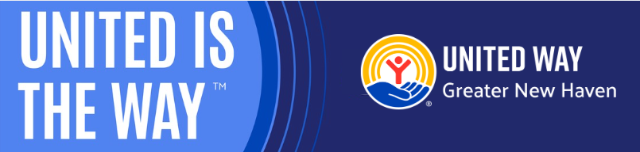
Subject Line: United is the Way in Greater New Haven
Preheader Text: We can make a bigger impact together.
Email Body:
[Name],
Join [Company Name] in making the change you want to see in your community.
Your support of United Way of Greater New Haven will allow us to build healthy communities, support child development, and create financial security to ensure our neighbors can thrive. Our work is powered by generous supporters, like you and [Company Name], who believe United is the Way to building local resilience.
Together with our community-serving partners and supporters like you, we can connect people to the opportunities they need to reach their full potential and make Greater New Haven a place where everyone can thrive.
No challenge is too big for us to take on when we work together.
Because United is the Way. [Hyperlink Donation Page]
[Closing,]
Signature

EMAIL TEMPLATE 2: CEO Message
From: Company CEO, Leader, or Employee Campaign Chair’s first and last name
Audience: All company employees
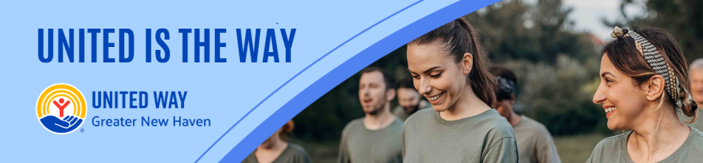
Subject Line: Join [Company Name] in building at thriving Greater New Haven!
Preheader Text: Today, so many of our neighbors are working hard to overcome barriers to build a life where they can thrive.
“Try to be a rainbow in someone’s cloud” - Maya Angelou
[Name],
Everyone deserves to be a part of a thriving community. United Way of Greater New Haven supports the needs of our neighbors every day to help strengthen our community. Working together, we can reach a future where everyone thrives. We’ve set an ambitious goal of raising [monetary goal/description] to help do just that.
I believe that when we come together as a team, there’s no challenge that can’t be solved. That’s why I’m inviting you to join me in striving toward positive change in Greater New Haven. This is more than a campaign – it is a call to action for us at [Company Name] to advance solutions to real problems facing people in the communities where we live and work.
Together, we’re increasing access to food and stable housing, advancing the well-being of children, promoting financial security, and working towards a better future for all. We’re counting on generous people like you and your teammates to help improve the lives of people in our community. Last year, with our support, United Way of Greater New Haven was able to impact 88,482 lives. And this year, with your help, we know that we can do even more. Make your gift today and be a force for good.
BUTTON TEXT: UNITED IS THE WAY [Hyperlink donation page]
[Closing]
Signature

Email Template 3: Mid Push
From: Your United Way CEO/CPO, Board or Campaign Chair’s first and last name
Audience: All company employees
Call to Action: Donate Today, United is the Way!
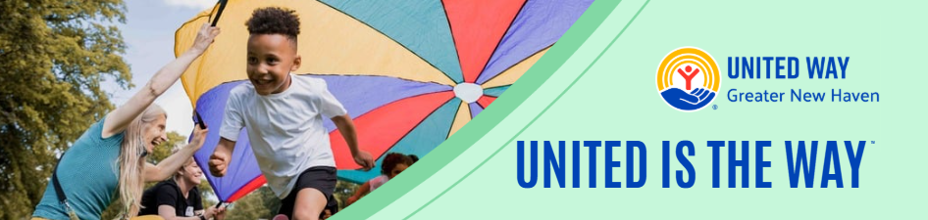
Subject Line: What can we do for children in Greater New Haven?
Preheader Text: Mobilizing our community and changing lives.
Email Body:
Hi [Name],
We need you with us-- whether you’re new to United Way of Greater New Haven or you’ve been creating impact with us for years.
We are building a foundation for children to learn, grow, and truly thrive. Educators, caregivers, and parents are learning to adapt the way they interact with children to deepen connection and trust with children, while learning more about themselves in the process.
Day in and day out, United Way funds programs that meet the most urgent needs in our Greater New Haven community. We’ve pioneered and expanded programs like the Secure Start Initiative that support parents and early childhood educators in promoting children’s healthy development.
"This was eye opening and helps me to be an emotionally mature and intuitive person with a lot more empathy." – Secure Start Parent.
More work is needed to build on this momentum. If you’ve already given, thank you. If you haven’t, there’s still time to join in!
BUTTON TEXT: Donate [Hyperlink]
United is the Way to making great things happen for people who call Geater New Haven home.
[Closing]
Signature

EMAIL TEMPLATE: LAST PUSH
From: Company CEO, Leader, or Employee Campaign Chair’s first and last name
Audience: All company employees
Call to Action: Last chance! Make your donation to our United Way campaign
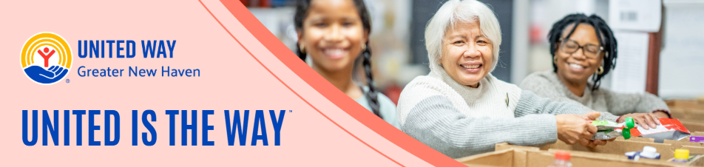
Subject Line: Now is the time, be a part of something bigger
Preheader Text: Time is running out!
Email Body:
Have you made your gift to [Company Name’s] United Way campaign?
Donate today and support our neighbors in accessing food, stable housing, childcare and education, and the resources to build economic mobility. 42% of households in Greater New Haven don’t make enough money to afford basic necessities like food, rent, and childcare.
Each year, United Way donors and volunteers come together to feed tens of thousands of children and adults through food distributions, pop-up pantries, summer meals for kids, serving prepared meals, and more.
“It’s been very hard to get by on our food budget. Everything is so expensive now. This food pantry is a big help for my family.” - Hamden Mobile Food Pantry client.
Employees at [Company Name] are chipping in and uniting to build a community where everyone has access to nourishing food.
BUTTON TEXT: Make your gift today! [Hyperlink]
Thank you for your continued support!
[Name],
[Closing],
Signature
EMAIL TEMPLATE: THANK YOU
From: Company CEO, Leader, or Employee Campaign Chair’s first and last name
Audience: All company employees
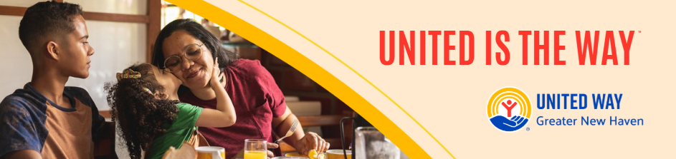
Subject Line: Thank You for Your Support
Email Body:
Dear [Donor Name],
Thank you for participating in our United Way campaign, because United is the Way to a thriving community. Your donation to United Way will support our work in meeting critical needs for children, families, and neighbors in our community.
Thank you so much, not just from me or [Company Name], but from the countless lives you have impacted with your generosity.
Sincerely,
[YOUR NAME HERE]
P.S. See your impact – join United Way’s email list, follow them on social media, or join in a volunteer event! [https://linktr.ee/UNITEDWAYGNH]

